Scripting Task

Task Description:
- Create a shell script to print the HTTP error code of guvi.in & print, the success/failure message based on the error code response
- Given a file, replace all occurrence of the word "give" with "learning" from 5th line till the end in only those lines that contain the word "welcome"

- HTTP error code:
This script is used to check the HTTP status code of a website (here: guvi.in) and print whether the request is successful or failed based on the response.
Script 1:
#!/bin/bash
response=$(curl -s -o /dev/null -w "%{http_code}" https://www.guvi.in)
echo "HTTP status code is: $response"
#print Success, Failure message
if [ "$response" -ge 200 ] && [ "$response" -lt 300 ];
then
echo "SUCCESS"
else
echo "FAILURE"
fi

Output:
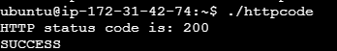
This script uses the curl command to send a request to the website and capture only the HTTP status code.
- curl -s → Runs silently (no progress output)
- -o /dev/null → Discards the response body
- -w "%{http_code}" → Prints only the HTTP status code
The status code is stored in a variable called response.
- If the status code is between 200 and 299, it prints SUCCESS
- This script is simple and mainly checks whether the website is reachable and working.
Script 2:
This script is an advanced version of Script 1.
- It also fetches the HTTP status code using curl
- But instead of just success/failure, it provides detailed classification of responses

#!/bin/bash
url="https://www.guvi.in"
response=$(curl -s -o /dev/null -w "%{http_code}" $url)

echo "HTTP status code is: $response"

case $response in
1??)
echo "Informational Response"
case $response in
100) echo "100 - Continue" ;;
101) echo "101 - Switching Protocols" ;;
102) echo "102 - Processing" ;;
103) echo "103 - Early Hints" ;;
esac
;;

2??)
echo "Successful Response"
case $response in
200) echo "200 OK - Request succeeded" ;;
201) echo "201 Created - Resource created successfully" ;;
202) echo "202 Accepted" ;;
203) echo "Non-Authoritative Information";;
204) echo "204 No Content - Success but no response body" ;;
205) echo "205 - Reset Content" ;;
206) echo "206 - Partial Content" ;;
207) echo "207 - Multi-Status (WebDAV)" ;;
208) echo "208 - Already Reported (WebDAV)" ;;
226) echo "226 - IM Used" ;;
esac
;;

3??)
echo "Redirection Message"
case $response in
300) echo "300 - Multiple Choices" ;;
301) echo "301 - Moved Permanently" ;;
302) echo "302 - Found" ;;
303) echo "303 - See Other" ;;
304) echo "304 - Not Modified" ;;
305) echo "305 - Use Proxy (Deprecated)" ;;
306) echo "306 - Unused" ;;
307) echo "307 - Temporary Redirect" ;;
308) echo "308 - Permanent Redirect" ;;
esac
;;

4??)
echo "Client Error"
case $response in
400) echo "400 Bad Request" ;;
401) echo "401 Unauthorized" ;;
403) echo "403 Forbidden - Access denied" ;;
404) echo "404 Not Found - Resource not available" ;;
405) echo "405 - Method Not Allowed" ;;
406) echo "406 - Not Acceptable" ;;
407) echo "407 - Proxy Authentication Required" ;;
408) echo "408 - Request Timeout" ;;
409) echo "409 - Conflict" ;;
410) echo "410 - Gone" ;;
411) echo "411 - Length Required" ;;
412) echo "412 - Precondition Failed" ;;
413) echo "413 - Content Too Large" ;;
414) echo "414 - URI Too Long" ;;
415) echo "415 - Unsupported Media Type" ;;
416) echo "416 - Range Not Satisfiable" ;;
417) echo "417 - Expectation Failed" ;;
418) echo "418 - I'm a teapot" ;;
421) echo "421 - Misdirected Request" ;;
422) echo "422 - Unprocessable Content" ;;
423) echo "423 - Locked" ;;
424) echo "424 - Failed Dependency" ;;
425) echo "425 - Too Early" ;;
426) echo "426 - Upgrade Required" ;;
428) echo "428 - Precondition Required" ;;
429) echo "429 - Too Many Requests" ;;
431) echo "431 - Request Header Fields Too Large" ;;
451) echo "451 - Unavailable For Legal Reasons" ;;
esac
;;

5??)
echo "Server Error"
case $response in
500) echo "500 Internal Server Error" ;;
501) echo "501 - Not Implemented" ;;
502) echo "502 Bad Gateway" ;;
503) echo "503 Service Unavailable" ;;
504) echo "504 - Gateway Timeout" ;;
505) echo "505 - HTTP Version Not Supported" ;;
506) echo "506 - Variant Also Negotiates" ;;
507) echo "507 - Insufficient Storage" ;;
508) echo "508 - Loop Detected" ;;
510) echo "510 - Not Extended" ;;
511) echo "511 - Network Authentication Required" ;;
esac
;;

*)
echo "Unknown Status Code"
;;
Esac

Output :
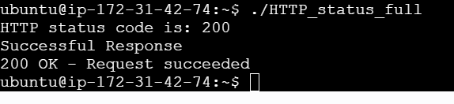
It uses a case statement to group responses:
Response Categories:
- 1xx → Informational responses
- 2xx → Successful responses
- 3xx → Redirection messages
- 4xx → Client errors
- 5xx → Server errors
Inside each category, another case block gives specific meaning of each code (like 200 OK, 404 Not Found, etc.).

- Given a file, replace all occurrence of the word “give” with “learning” from 5th line till the end in only those lines that contain the word “welcome”

Task Description:
The task is to modify a file by:
- Starting from line 5 till the end
- Only selecting lines that contain the word "welcome"
- Replacing all occurrences of "give" with "learning"

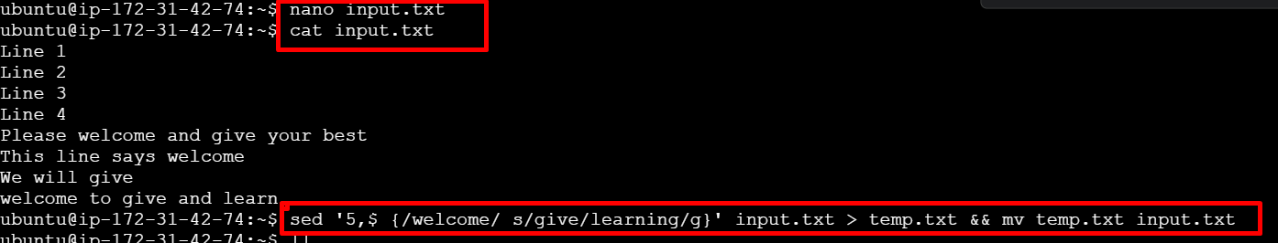
sed '5,$ {/welcome/ s/give/learning/g}' input.txt > temp.txt && mv temp.txt input.txt

Output :
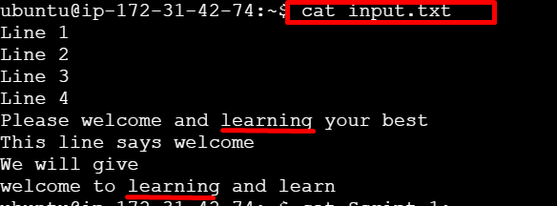
Script Explanation:
- 5,$ → Selects lines from line 5 to the last line
- /welcome/ → Filters only lines containing the word "welcome"
- s/give/learning/g → Replaces all occurrences of "give" with "learning"
- > temp.txt → Stores the modified output in a temporary file
- mv temp.txt input.txt → Replaces the original file with the updated content

